**Site Issues Management Plan**

**Hawksdale Estate**

Hawksdale Estate, Little Widget, England

Wates Construction

xx.xx.xxxx Rv1

**Contents**

**1.0 ………………………….. Introduction**

**2.0 ………………………….. Identified Issues**

**3.0 ………………………….. Protected Species**

**4.0 ………………………….. Invasive Species**

**5.0 ………………………….. Contaminated Ground**

**6.0 ………………………….. Site Sustainable Drainage**

1. **Introduction**

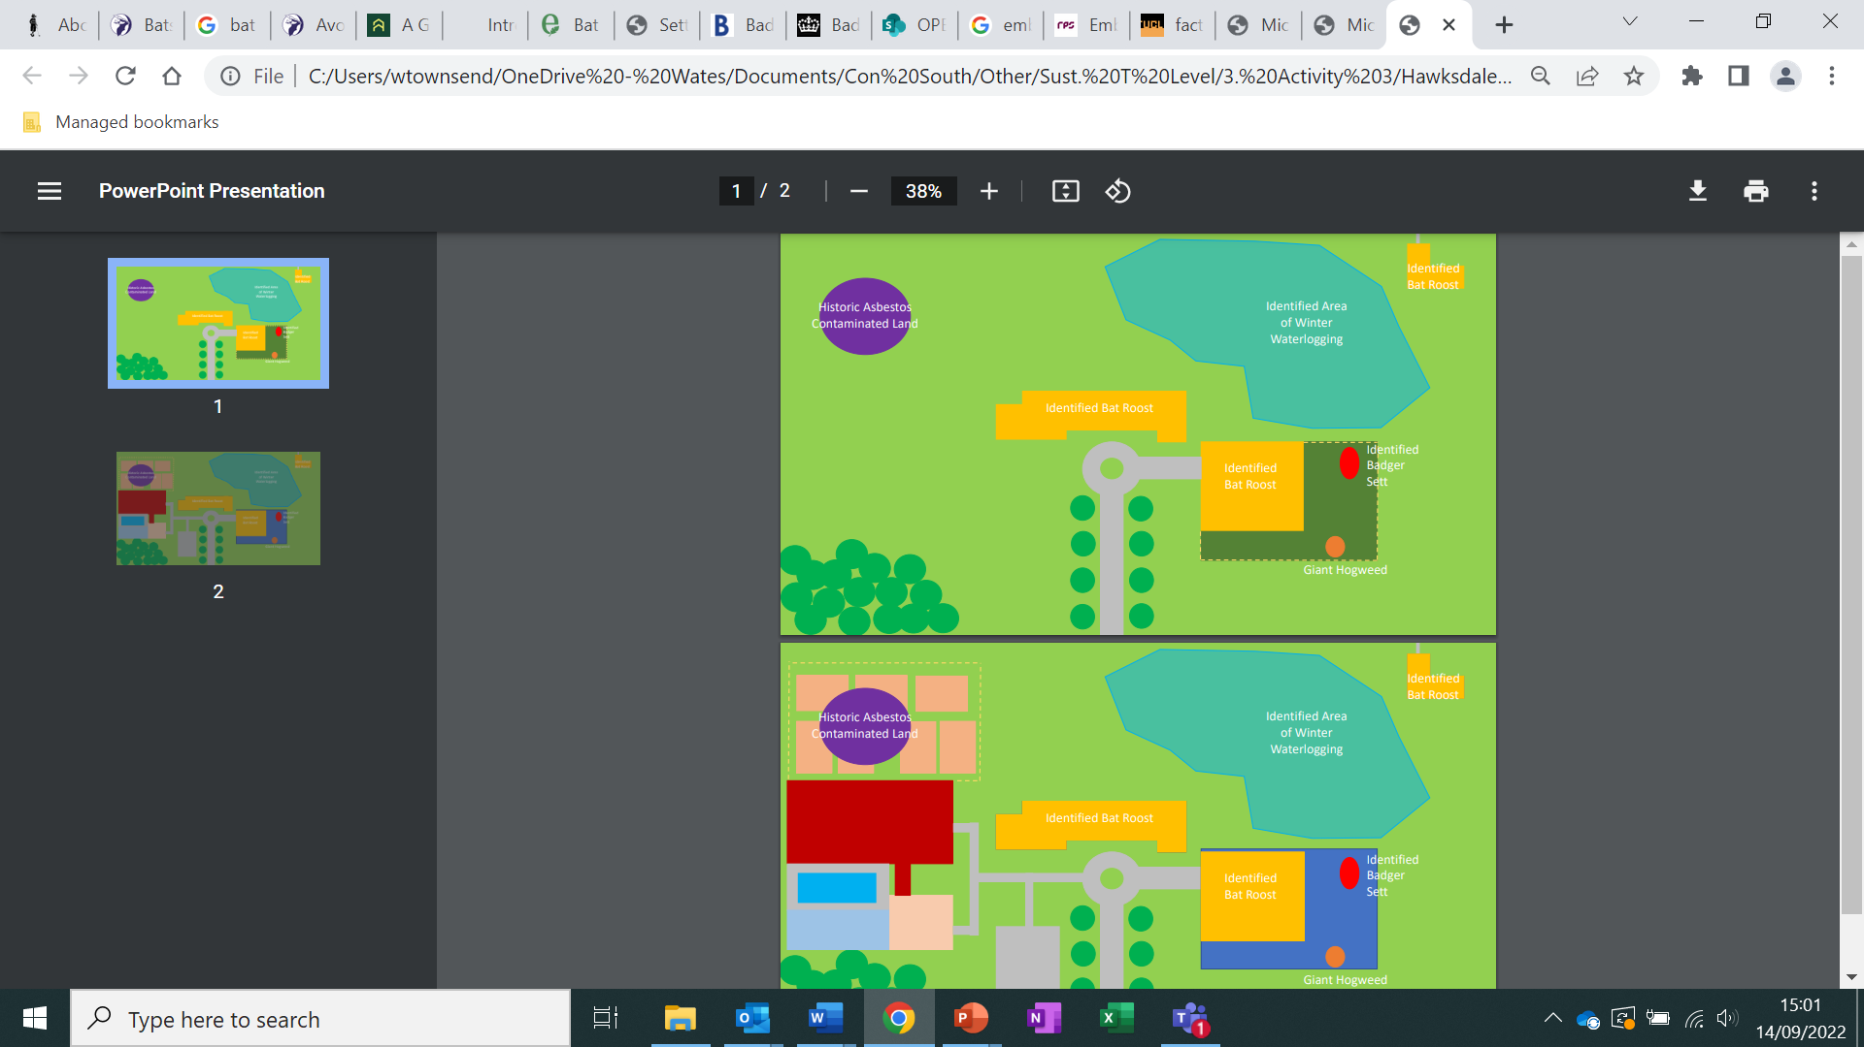

* 1. The aim of this Site Issues Management Plan (SEMP) is to set out proposed management strategies for a range of environmental issues identified on the project site.

1. **Identified Issues**
   1. The Below is a list of issues identified on the project site in need of management
      1. A sett of Badgers was identified on the perimeter fence of the disused Stable field. These Badgers are located under the proposed new location of the additional accommodation building and so would be directly effected by operations.
      2. A number of bats have been identified entering and exciting the buildings across the project site. Given the time of year being early spring the ecologist has advised that is likely that these are only transitional roots.
      3. Several stems of Giant Hogweed have been identified within the disused field behind the Stable. This invasive species requires remediation and exists on land proposed for the development of the new accommodation building
      4. An area of land to the North West of the site has been identified as being contaminated with asbestos through unknown activity prior to the client’s ownership. This land is considered to be contaminated with Asbestos and in need of appropriate management.
      5. An area of the project site is prone to waterlogging. With an increase in hard standing coverage increasing run off the rate of flood has been identified as a risk. Additionally, with the intent for the gardens to be used for public and hotel user recreation the client has a desire to manage this issue to reduce the waterlogging and reopen the space to year-round use.
   2. Appropriate management suggestions are proposed in each relevant section.
2. **Protected Species**
3. **Invasive Species**
4. **Contaminated Ground**
5. **Site Sustainable Drainage**