**Embodied Carbon Reduction Plan**

**Hawksdale Estate**

Hawksdale Estate, Little Widget, England

Wates Construction

xx.xx.xxxx Rv1

**Contents**

**1.0 ………………………….. Introduction**

**2.0 ………………………….. Project Embodied Carbon Baseline**

**3.0 ………………………….. Reduction Options for Consideration**

**4.0 ………………………….. Site Carbon Reduction Suggestions**

1. **Introduction** 
   1. The aim of this document is to propose a plan for minimising the embodied carbon impact of the Hawksdale estate.
   2. Suggestions within this document will be high level suggestions at potential changes and management routes to reduce impact without numerically linked data.
2. **Project Embodied Carbon Baseline**

The project’s embodied carbon baseline has been calculated as demonstrated below. Key contributing materials are identified below.

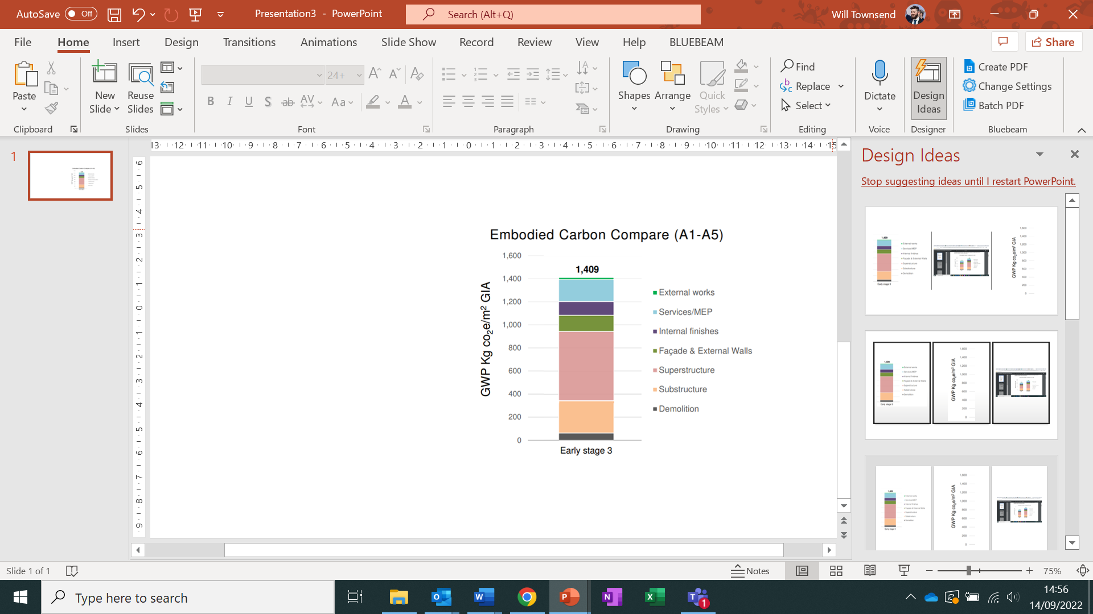

**Key Materials**

* Reinforced Concrete (Foundations and Basements)
* Structural Steel (Steel building Frames)
* External Building Brickwork
* External Tiling for facades
* Roofing secondary steel
* Additional Metalwork
* Gysum for internal walling
* Raised Access Flooring
* External concrete and pavement for landscaping

1. **Reduction Options for Consideration**
2. **Site Carbon Reduction Initiatives**