**Site Environmental Management Plan**

**Hawksdale Estate**

Hawksdale Estate, Little Widget, England

Wates Construction

**Contents**

**1.0 ………………………….. Introduction**

**2.0 ………………………….. Regulatory Framework and Planning Conditions**

**3.0 ………………………….. Site Location & Project Description**

**4.0 ………………………….. Construction Programme**

**5.0 ………………………….. Roles & Responsibilities**

**6.0 ………………………….. Information for contractors and visitors**

**7.0 ………………………….. Environmental Assessment**

**8.0 ………………………….. Ecology – Biodiversity Net Gain & Protected Species**

**9.0 ………………………….. Heritage & Archaeology**

**10.0 ………………………….. Transport & Logistics Management**

**11.0 ………………………….. Site Waste Management**

**12.0 ………………………….. Renewable Energy & Sustainable Technology**

**13.0 ………………………….. Incident Response**

**14.0 ………………………….. Internal Communication and Training**

**15.0 ………………………….. External Communication**

**16.0 ………………………….. Other Comments**

1. **Introduction** 
   1. The aim of this Site Environmental Management Plan (SEMP) is to set out the responsibilities and requirements with regard to legal and regulatory compliance and the implementation of Environmental Management Systems and Mitigation measures.
   2. This SEMP details procedures and plans for the avoidance, minimisation and mitigation of potential environmental impacts as a result of the construction phase of works in accordance with the mitigation hierarchy.
   3. These plans constitute a framework of measures, targets and monitoring strategies for the environmental management of the project’s construction phase.
   4. All of these plans and procedures are bespoke to the project and exist within a dynamic system of management which will be reviewed and edited throughout the progression of the project.
   5. The development of the document has been developed with the aim of managing environmental impact of any construction activities in accordance with the Mitigation Hierarchy. As such it should be regarded as a guidance document subject to change and review as environmental risks and potential impacts change during project progression.
   6. For the purposes of this SEMP the definition of “Working Area” was defined as “any area that will require either temporary of permanent works to facilitate the progression of the development’s construction phase.” This includes areas required for access, temporary construction works and temporary storage areas.
2. **Regulatory Framework and Planning Conditions**
   1. The primary requirements of the planning consent are the implementation of the core document; the Site Environmental Management Plan (SEMP). The SEMP is required to encompass environmental controls when required with due consideration to relevant environmental legislation.
   2. The SEMP provides the framework for which commitments made in the Environmental Statement (ES) or any requirements of planning conditions can be realised. The SEMP outlines the contractor’s approach to environmental management throughout the construction phases with the primary aim of reducing any adverse impacts from construction on local sensitive receptors and managing the sustainability impacts of the project’s development.
3. **Site Location & Project Description**

The Hawksdale Estate is set within the iconic Historic Widget area the estate is widely known for its gardens and heritage 16th Century frontage. The church on the site’s perimeter is still in use by the public and highlights how the historic importance of the estate to the local area has continued into the present day The project comprises several existing heritage buildings with the intent of reinvigorating the historic estate to deliver a state of the art hotel centre with onsite spa, exercise and leisure facilities.

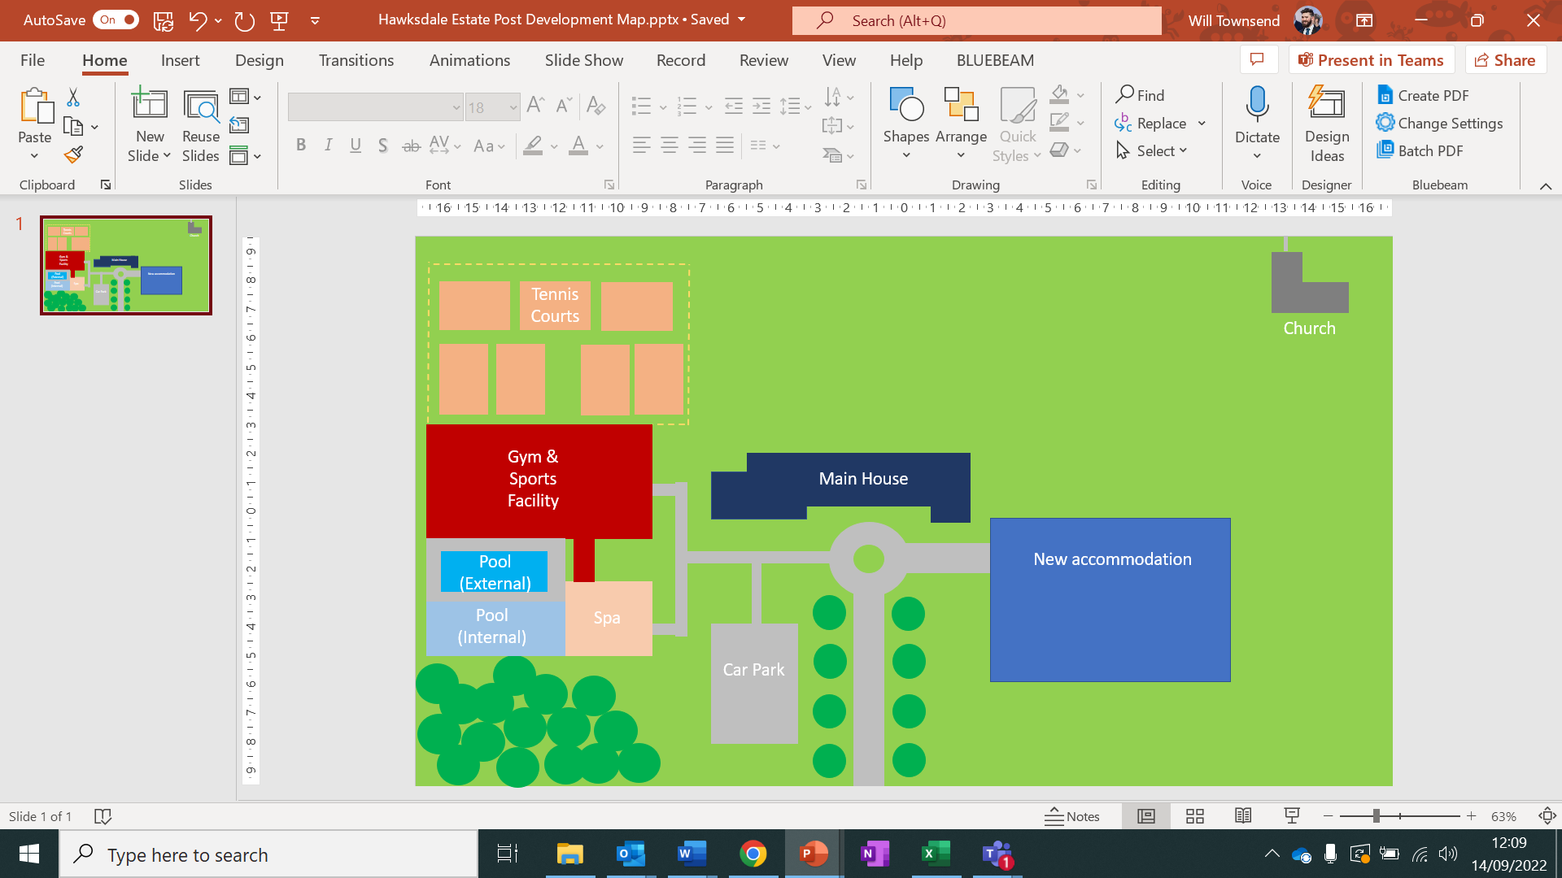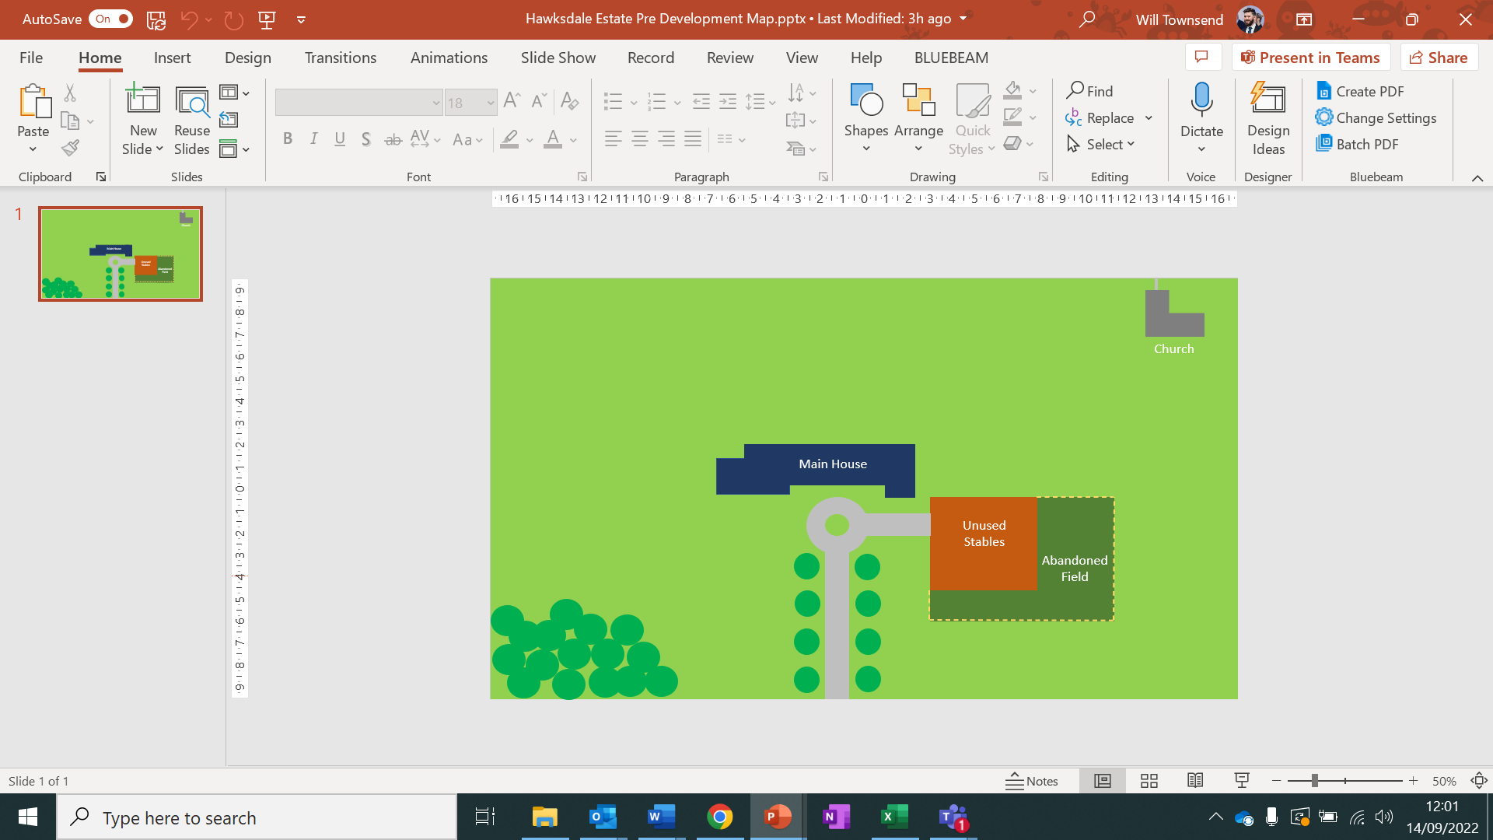

Plate 2. The Hawsdale Estate Post-Development

Plate 1. The Hawsdale Estate Pre-Development

The estate exists in the area of Little Widget, a historic town featuring a large area of residential with its key features being the Primary school, Secondary School and Superstore – operational details for each are listed below.

Primary School

* Days – Mon – Fri
* Open – 09:00
* Close – 13:30

Secondary School

* Days – Mon-Fri & Sat Morning
* Open – 08:30
* Close – 16:30

Super Store

* Days – 7 Days / week
* Open – 07:00
* Close – 22:00 Mon-Sat, 18:00 Sun
* Deliveries – 05:30-06:30 & 22:00 – 23:00 Mon-Fri

1. **Construction Programme**
   1. The detailed Construction Programme will be made available for review in the site office.
   2. The key dates presented in the programme are as follows:
      1. Year 1 Spring – Project commencement
      2. Year 1 Summer – Main demolition and enabling works
      3. Year 2 Spring – Main construction works commence
      4. Year 2 Winter – Superstructure Frame Completion
      5. Year 3 Spring – Building Envelopment & Fit out
      6. Year 3 Autumn – Project close
   3. A full copy of the construction programme will be available from the Construction Manager.
2. **Roles & Responsibilities** 
   1. The Construction Manager is responsible for:
      * Ensuring that the SEMP is developed & held on site and that it is implemented throughout all phases of the project. Ensuring the SEMP details are updated as and when relevant information is provided by the stakeholders associated with each section of the SEMP; e.g. further consent conditions, pre-construction surveys, etc.
      * Maintaining the SEMP and ensuring that all contractors and visitors comply with it.
      * Ensuring that environmental issues identified within the Pre-Construction Information and the pre-construction site surveys and relevant information gathered from agencies, local councils etc are addressed.
      * Producing environmental project specific controls for all significant risks identified and implementing control measures to minimise the risk of damage to the environment.
      * Communicating the SEMP and other related document to employees, contractors and client representatives.
      * Ensure the site and all stored materials and chemicals are safe and secure.
      * Wates signage indicating where and whom visitors should report to are clearly displayed, the site is kept in a tidy and orderly fashion. Waste will be managed in conjunction with the Wates group procedure.
      * Controlled access arrangements as so those entering site may avoid hazards.
      * Emergency egress arrangement so those leaving site in the event of a pollution or spillage incident may do so safely.
      * There are First Aid Facilities and appropriately trained First Aid staffs, spill kits are available and appropriately trained staff.

Ensure all those that work on site:

* + - Have Wates Site Induction including briefing on environmental issues pertinent to the project and relevant toolbox talks.
    - Understand and obey the Site Rules.
    - Are made aware of the Emergency egress arrangements, Muster points, First Aid facilities and First Aiders, spill and clean up procedures.
    - Read and understand the site hazard board.
    - Have current certification for activities as required.
    - Are aware of all environmental matters which arise on site.

Ensure the activities on site:

* + - When necessary are carried out under Client Operational Safety Rules.
    - Have task specific risk assessments and method statements (RAMS) in place identifying any environmental issue which may be applicable.
    - Are carried out in accordance with the requirements of any associated RAMS.
  1. The site Safety, Health & Environment Advisor (SHE Advisor) is responsible for:
     1. Ensuring work is carried out:
* In a safe manner.
* In accordance with any manufacturers’ instructions etc., good standards of workmanship.
* Ensure site staff are working in accordance with agreed Risk Assessments and Method Statements (RAMS) particularly where activities have the potential to cause environmental harm.
* Health and safety advisor to complete the site waste management plan and ensure it is followed.
* Ensuring that the SEMP is implemented throughout all phases of the project.
  + 1. Monitoring SHE issues by:
* Carrying out regular checks on site to ensure the site is secure and tidy.
* Monthly audits.
* Consulting workers on the effectiveness of measures to reduce risk to the environmental, reviewing and improving conditions or methods/procedures where appropriate.
* Keeping records of and reporting any incidents and close calls (near misses).
  1. The Environmental Manager shall be responsible for:
     1. Ensuring that the SEMP is developed & held on site and that it is implemented throughout all phases of the project. Ensuring the SEMP details are updated as and when relevant information is provided by the stakeholders associated with each section of the SEMP; e.g. further consent conditions, pre-construction surveys, etc.
     2. Maintaining the SEMP and ensuring that all contractors and visitors comply with it.
     3. Ensuring that work is carried out:
* In accordance with legislation & consents, objectives, targets and the Construction Environmental Management Plan with regards to any environmental activities on site.
* Ensure site staff operates in accordance with agreed Risk Assessments and Method Statement (RAMS) and in accordance with the Wates induction and tool box talk training with regards to environmental risk.

5.5.4 Monitor/Report Environmental Issues by:

* Carrying out weekly checks and “toolbox talks” carried out and recorded as necessary
* Carrying out Monthly Audits of Environmental Data and Statistics
* Ensuring compliance with Environmental legislation & consents, objectives, targets and the Construction Environmental Management Plan.
* Carrying out Inspections, Audits and Non – conformance reports.
* Responsible for delivering environmental training.
* Environmental Advisor to liaise with Health and Safety advisor to complete the site waste management plan and ensure it is followed.
* Environmental performance data reporting.
* Ensure work is carried out in accordance with the Environmental Statement.
* Compliance with environmental legislation, consents, objectives, targets and other environmental commitments.

1. **Information for contractors & visitors**
   1. All contractors and visitors to the site will be made aware of the Environmental Policy and the controls applicable to their presence and activities on site including but not limited to:
      1. Method Statements
      2. Risk Assessments
      3. Site inductions containing environmental briefings
      4. Tool box Talks
   2. The Project Manager will be responsible for monitoring communications between all relevant parties to the project ensuring that all environmental matters to the project are discussed and managed and observation of the communications will be documented in the weekly site meetings and sent by e-mail. In addition, a copy of all correspondence will be held in this file.
   3. Relevant Site layout and locations / plans / CDM drawing detailing the location and construction of the site compound, storage locations and car parking are to be displayed on an information board at the site entrance.
2. **Environmental Assessment**
   1. An environmental scoping assessment to identify potential environmental impacts of the project has been carried out. This assessment was undertaken in a number of ways including a formal risk assessment process or a comprehensive site assessment.
   2. The SEMP does not require all components of the environmental scoping assessment depending upon the outcomes of the assessment.
   3. The assessment considers each work activity to be undertaken and the potential for them to impact on the environment. The assessment provides details on the rating system used to determine the level of consequence and likelihood.
   4. The Project Environmental Statement was coordinated on behalf of Wates Construction by William Townsend. The environmental statement serves to provide a statement of intent surrounding sustainable operations in relation to factual information about the potential significance of likely environmental impacts.
   5. The assessment examined the following environmental aspects:
      1. Ecology
      2. Archaeology & Cultural Heritage
      3. Transport & Logistics Management
      4. Materials Sourcing
      5. Site Waste Management
      6. Renewable Energy & Sustainable Technology
   6. Where applicable, elements of the ESA are utilised in the SEMP to produce a practical outline plan for the management of the environmental risks of the projects’ construction phase.
3. **Ecology – Biodiversity Net Gain & Protected Species**
4. **Heritage & Archaeology**
5. **Transport & Logistics Management**
6. **Responsible Materials Sourcing**
7. **Site Waste Management**
8. **Renewable Energy & Sustainable Technology**
9. **Internal Communication & Training**

The SEMP will be distributed to the project team, including subcontractors, to ensure that the environmental requirements are communicated effectively. Key activities and environmentally sensitive operations will also be briefed to staff & subcontractors. Project, client and company environmental policies shall be displayed on site.

A schedule of meetings will be developed to include weekly safety, health and environment meetings. At these meetings any issues or incidents will be raised and communicated with the client, along with proposed remedial and mitigation actions and additional controls as required. An environmental register must be signed and updated to confirm tool box talks, training and weekly meetings by the environmental team.

During the construction phase, internal communication will include reporting on the following: Inspections, audits and non-conformance, environmental performance data including any incidents, near misses and progress on reaching targets. Group SHEQ-S and the account director will be informed of any visits by external bodies and the outcome or feedback of any such events.

Site staff will be competent to perform tasks that have potential to cause environmental impact. Competence s defined in terms of appropriate education, training and experience. Where project specific training is required, training will be appropriate to the role and seniority of staff.

Environmental awareness and training shall be achieved by:

All managers and supervisors to be briefed on the SEMP. All sub-staff and operators are to undergo an environmental induction and tool box talks and the SEMP will be signed and updated on the environmental register.

Site inductions, including relevant environmental issues such as waste management, working near watercourses, noise & dust managements and ecological risks

Emergency preparedness and response briefings, including communication and reporting of incidents, use of spill kits and other equipment.

Method statement and risk assessment briefings including reference to environmental risks

Toolbox talks to cover specific task related matters of environmental risk

Key project specific environmental issues and briefings

Meetings provide the project manager and team an opportunity to exchange information and receive immediate feedback

1. **External Communications**
   1. All complaints or information requests will be made aware to the Project Manager and will be logged promptly. A Public Liaison Officer will be appointed from Wates & identified to local residents and the public. They will serve as the first point of contact for members of the public.
   2. Noise may be a key subject of complaint where construction works take place very close to residential and retail areas. Working hours, plant types, construction methods and noise mitigation measures may be subject to section 61 consent under the Control of Pollution Act 1974. This will be applied for via the local authority and a mitigation plan developed leasing with local environmental authorities.
   3. The local authority environmental health team will be first point of contact for residents affected by noise, dust or other nuisance issues with the potential requirement that they be kept informed on progress, programme and upcoming phases of works that may give rise to disturbance in order to develop plans and respond to complaints.
   4. Careful monitoring of complaints received, including recording details of the location of the affected party, time of the disturbance and nature. This is to assist with managing the works to reduce the likelihood of further complaints.
2. **Other Comments**
   1. In addition to the mitigation measures, Wates maintain an Environmental Management System (certified to ISO14001) from which information will be extracted as required to complete method statements upon which operatives will be briefed.
   2. A commitments register for the scheme will be maintained, including the commitments identified within the SEMP. This will include any additional surveys, authorisations, consents, licenses and permissions required by the project in service of the construction operations of the development. The register will be updated with any new issues identified during the pre-construction or construction phase.