**T-Level Example Question – Pythagoras Theorem + Ramps**

You may come across the need to calculate gradients of ramps and slopes. The most common occurrence of this is working with ramped access to buildings, groundworks and so on. Slopes can be measured in angles, percentages, and ratios.

Here, the focus is on the measurement of slopes in ratios, mainly because gradient ratios are stated in the building regulations. At the end, there will be a quick look at slope percentages and how to work them out.

Approved Document Part M of the building regulations specifies limits for ramp gradients for access to a building. If access to a building is too steep it is not deemed to be a safe access and creates difficulty for people in wheelchairs who may not have the strength to propel themselves up a slope or may have difficulty slowing down when descending a slope that is too steep. Some people find they need to stop frequently when ascending/descending ramp and therefore suitable landings are required at specified intervals to allow for this.

The table below shows the guidelines from the building regulations:

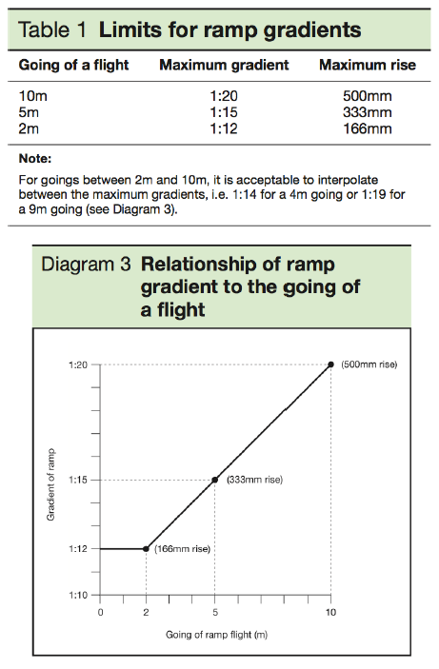

To work out the gradient of an existing slope you will need the distance of the slope (run) and the height of the slope (rise). The method that follows may not be the most mathematical way to work out the ratio gradient of a slope – but it is simple.

Remember to convert units so they are the same. For example, we have a 10m ramp run and a rise of 500mm. Convert the run to 10,000mm.

How to work out the gradient:

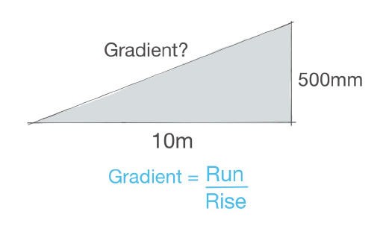

Example:

We want to work out the gradient of a ramp that has a run of 10m and a rise of 500mm.

Gradient = Run / Rise

Gradient = 10m / 500mm

Convert the units:

Gradient = 10,000mm / 500mm

Gradient = 20

**Gradient = 1:20**

How to work out the rise:

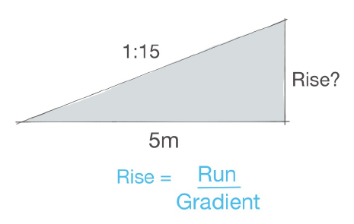

We want to work out the rise of a ramp that has a run of 5m and a gradient of 1:15.

Rise = Run / Gradient

Rise = 5m / 15

Convert the units:

Rise = 5,000mm / 15

**Rise = 333mm**

How to work out the run:

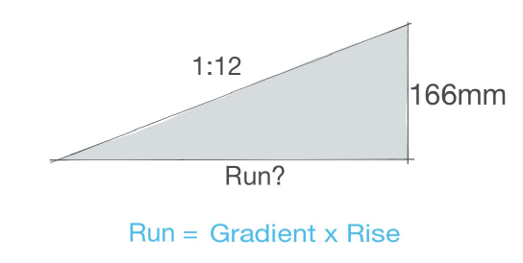

We want to work out the run of a ramp that has a rise of 166mm and a gradient of 1:12.

Run = Gradient x Rise

Run = 12 x 166mm

Run = 1,992mm

**Run = 1.99m (round up to 2m)**

How to work out the slope percentage:

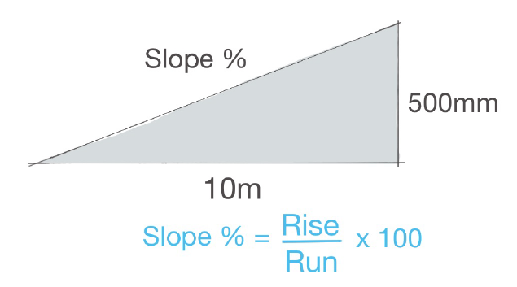

If we want to work out the percentage of a slope, you first must ensure you convert the units, so they are the same, similar to working with the ratios above.

Working on one of the previous examples, let’s assume we have a slope that has a run of 10m with a rise of 500mm. First convert the units.

Rise: 500mm

Run: 10,000mm

Percentage of slope = Rise / Run x 100

Percentage of slope = 500 / 10,000 x 100

**Percentage of slope = 5%**

**Question**:

1. Calculate the gradient of a ramp that is 12m in length with a rise of 710mm
   1. Would this ramp be compliant with Building Regulations?
   2. If not, what adjustments would be required to be made
2. Calculate the rise of a ramp that has a length of 6m with a rise of 390mm
   1. Would this ramp be compliant with Building Regulations?
   2. If not, what adjustments would be required to be made
3. Calculate the run of a 1:12 ramp that has a rise of 1.1m
   1. Would this ramp be compliant with Building Regulations?
   2. If not, what adjustments would be required to be made

Consider whether any of the above ramps would require landings to ensure compliance with building regulations.